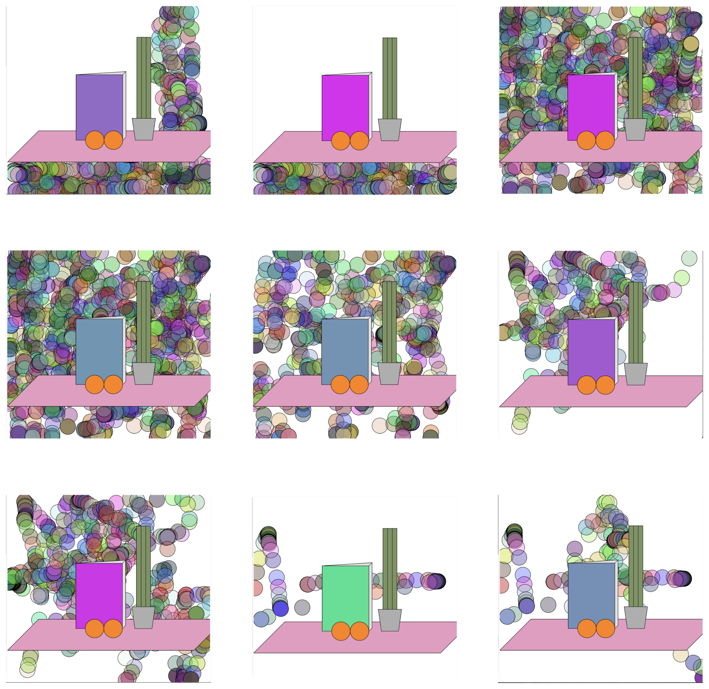

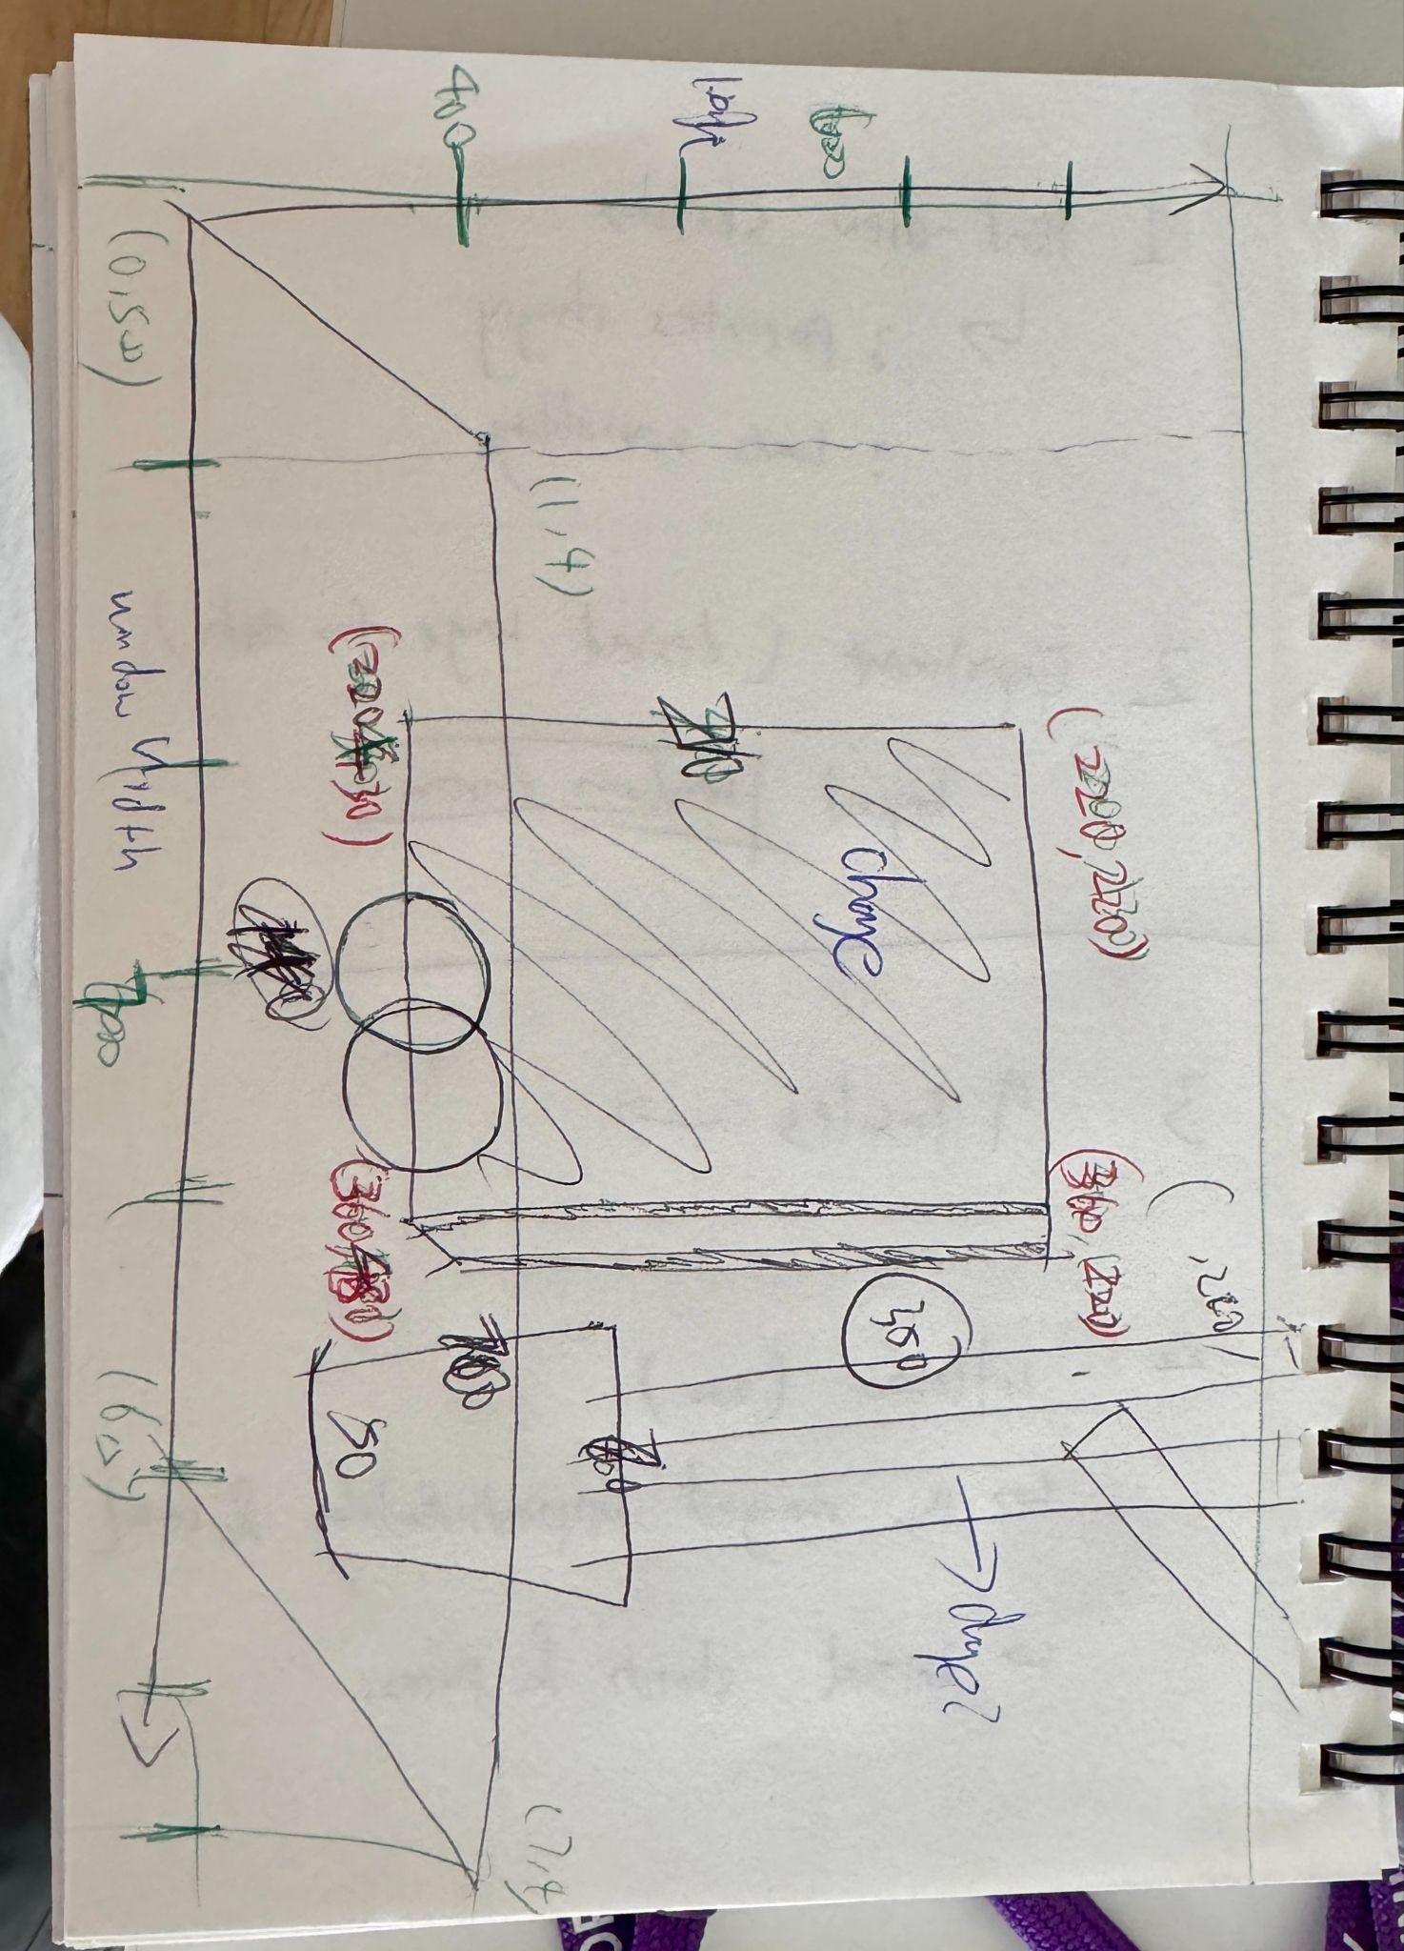

I was reworking our class project and started with this version. Initially, I aimed to make the book’s color change as the mouse moved. To do this, I used the mousePressed function and tried setting the RGB values randomly with random(255). However, I quickly realized that it made the screen too flashy with the background color changing unpredictably as I moved the mouse. To fix this, I redefined the book’s RGB values using the map function, which allowed me to control how the color changed smoothly.

For the red channel, I mapped mouseX from [0, windowWidth] to [0, 255], so the book gets redder as the mouse moves to the right. For the green, I mapped mouseX from [255, 0], making the book less green as the mouse moves right. I also mapped the blue channel from [128, 255] to ensure a consistent blue presence, even when the mouse is on the left.

I also incorporated a colorful background technique we learned. Throughout the process, there were noticeable gaps between my original sketch and the actual result. I’m still working on figuring out how to make the greens change color when clicked and how to move the oranges when clicked, as I’m having trouble controlling the mouse click range. When I sketch on paper, I find it difficult to represent real distances accurately when translating them into code. I often have to adjust the coordinate points over and over to get them right. For example, when I was drawing the vase, I initially wanted its height to be half the size of the book, but the coding result was very different from what I expected. In fact, the vase should be about one-third the size of the book.